One liner

Mark Jones is Australia’s Master Storyteller for business leaders.

Short bio
Mark Jones is Australia's Master Storyteller for business leaders. A highly acclaimed speaker, facilitator and business leader, he helps people tell their story to make an impact. A former journalist and Silicon Valley editor, he combines media smarts with tech savvy, and wisdom for leadership. Mark developed the world’s first brand storytelling framework, published in his book Beliefonomics. A husband and father of four, he puns with intent.

Long bio

Mark Jones is Australia's Master Storyteller for business leaders.
A highly acclaimed speaker, facilitator and business leader, he helps people tell their story to make an impact. Mark is a former technology editor at the Financial Review, Silicon Valley journalist and Australian entrepreneur.
He co-founded ImpactInstitute, an award-winning professional services firm and proud B Corp. which offers storytelling, impact advisory and event services. He also co-founded a pioneering event, Social Impact Summit, to foster long-term, sustained positive social change.
A curious learner, Mark has interviewed hundreds of CMOs on The CMO Show podcast for nearly a decade.
He believes storytellers change the world. His book, Beliefonomics: Realise the True Value of Your Brand Story, brought this idea to life with the world’s first brand storytelling framework.
Mark is a Certified Speaking Professional and serves on the National Board of Professional Speakers Australia. A husband and father of four, he puns with intent.

Stage intro – read before Mark walks on.

Mark Jones believes storytellers change the world.

As a speaker, author and executive impact coach, he helps leaders and brands tell their story to make an impact.

He’s a former technology journalist and editor at the Australian Financial Review, survived the dot-com crash while working in Silicon Valley and co-founded a professional services firm now called ImpactInstitute – 15 years strong, and growing.

And finally, he’s authored a book on brand storytelling called Beliefonomics, and began podcasting before it was cool. The CMO Show podcast is 9 years old and most of the 200+ marketing leaders he’s interviewed apparently still like him.

Here to share his story, offer rare insights and possibly pun with intent, please welcome to the stage, Mark Jones.

Photos

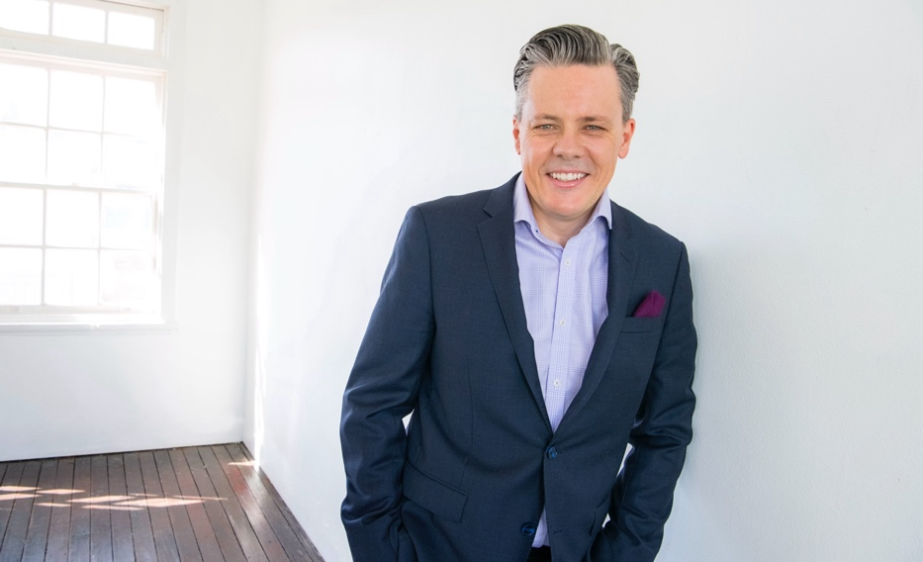

Topics
Visit: https://www.markjones.au/keynote-topics

Primary Category
- Leadership Development

Secondary Categories
- Sales & Marketing
- Storytelling for Business
- Technology, Innovation, Gen AI
- Personal Brand & Thought Leadership
- Purpose-driven Business, ESG & Social Impact

More info
Web markjones.au
LinkedIn https://www.linkedin.com/in/markhjonesimpact/
YouTube https://www.youtube.com/@MarkJones_Storyteller
Speaker Reel https://www.youtube.com/watch?v=LxH1EY_LdbU

